Postman Testing Screenshots:

1. Save Customer and his accounts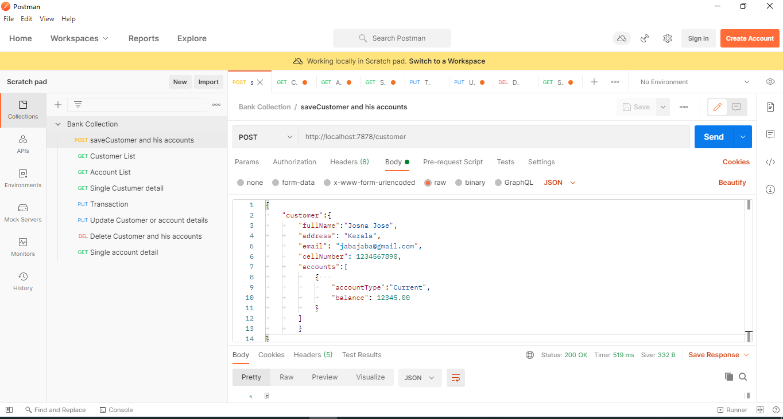
2. Customer List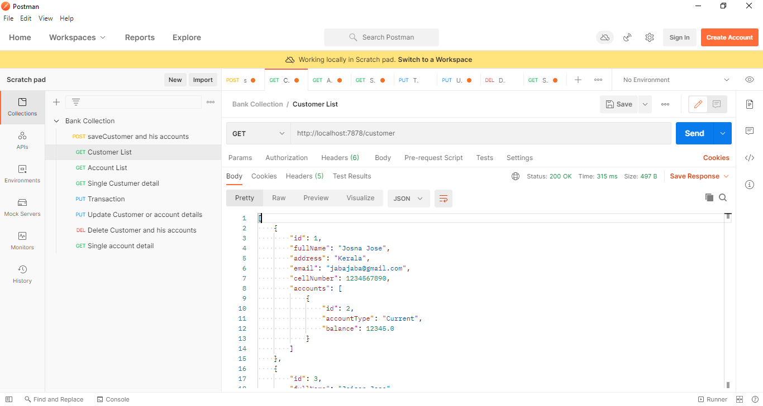
3. Account List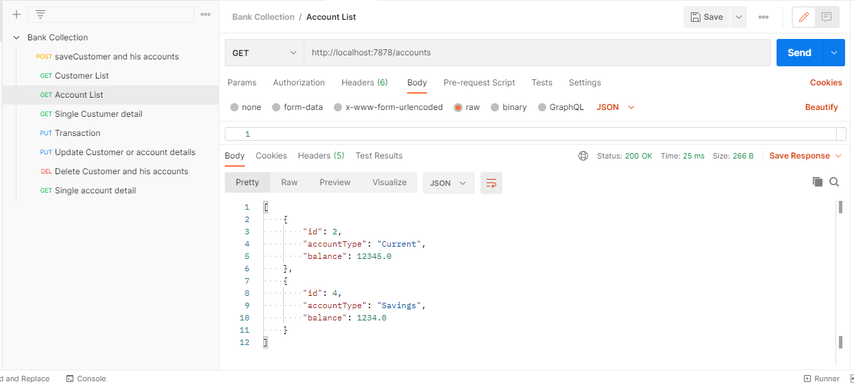
4. Single Custumer detail -found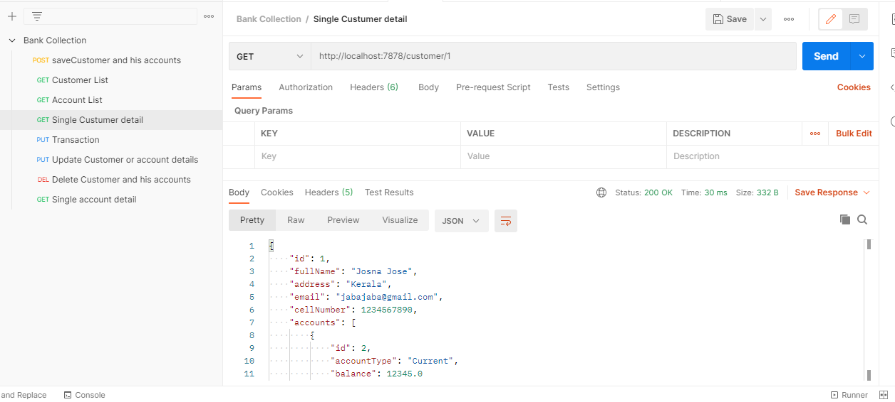
5. Single Custumer detail -not found 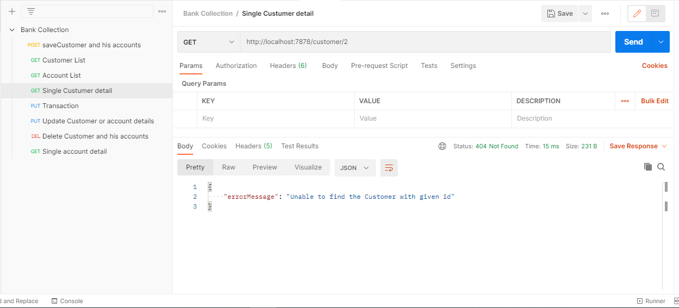
6. Transaction- wrong from account 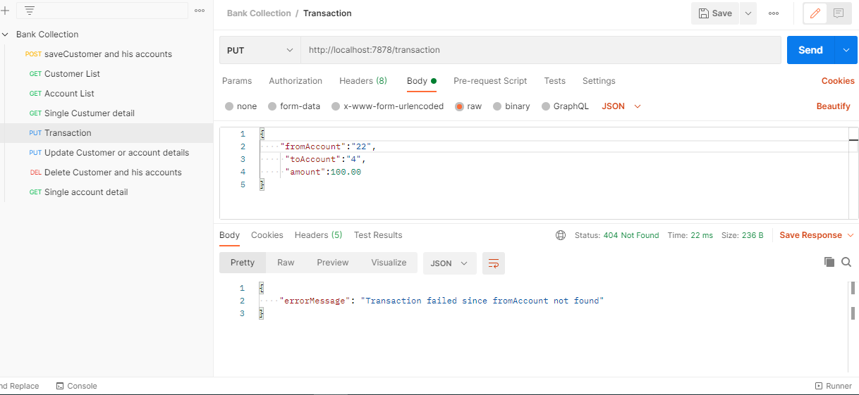
7. Transaction- wrong to account 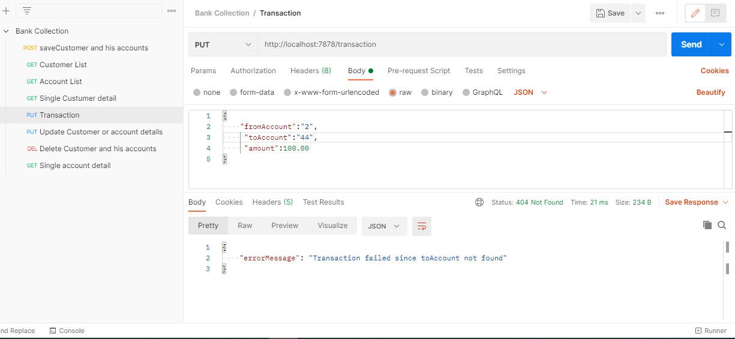
8. Transaction- Insufficient Balance 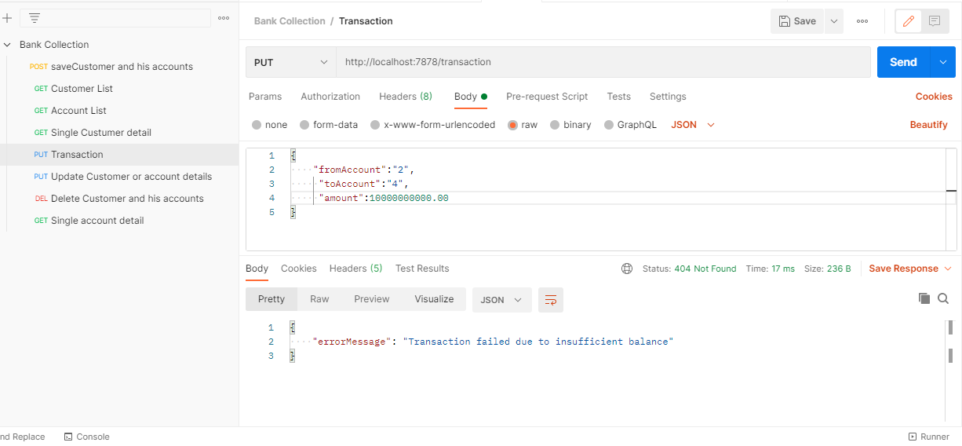
9. Transaction – Correct scenario 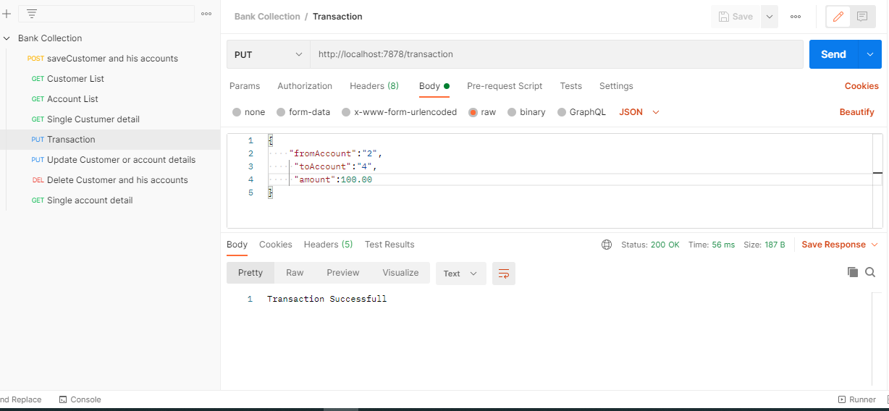
10. Update Customer or account details -Id not found 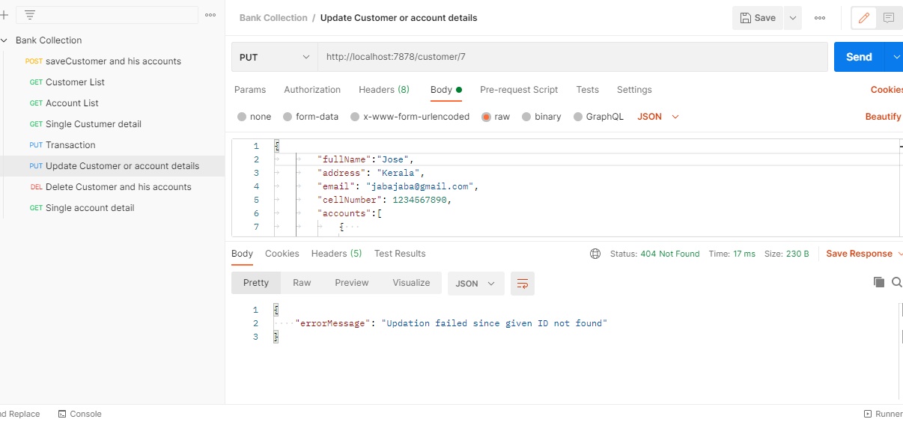
11. Update Customer or account details -Id found 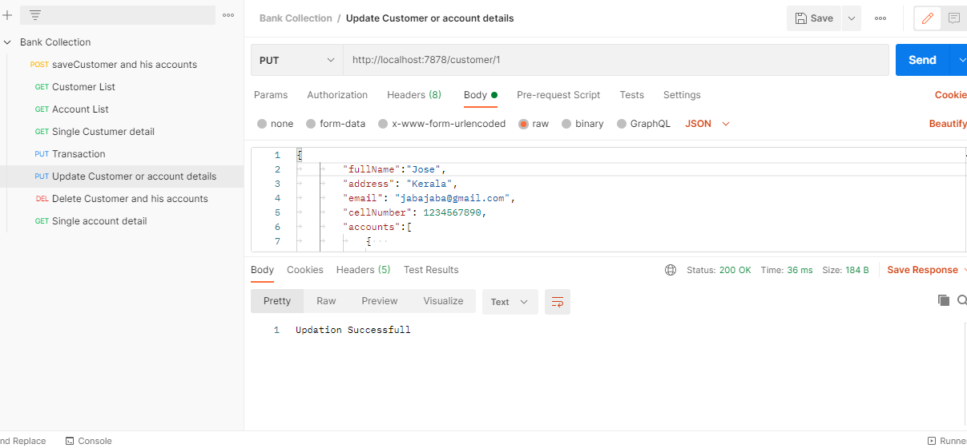
12. Delete Customer and his accounts – Id not found 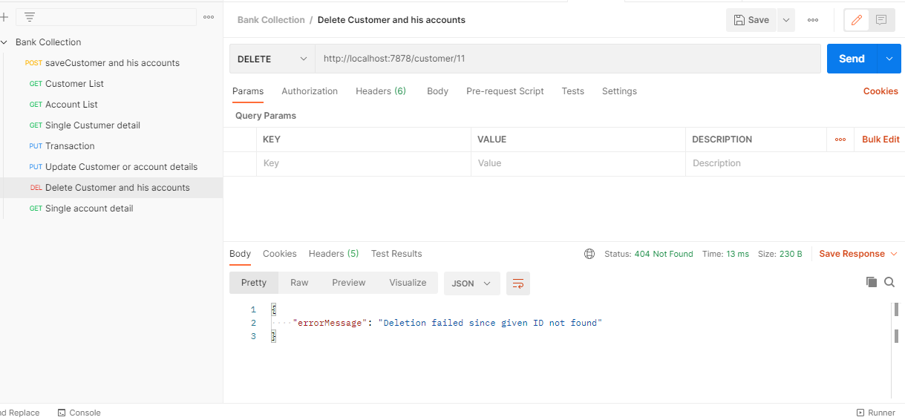
13. Delete Customer and his accounts – Id found 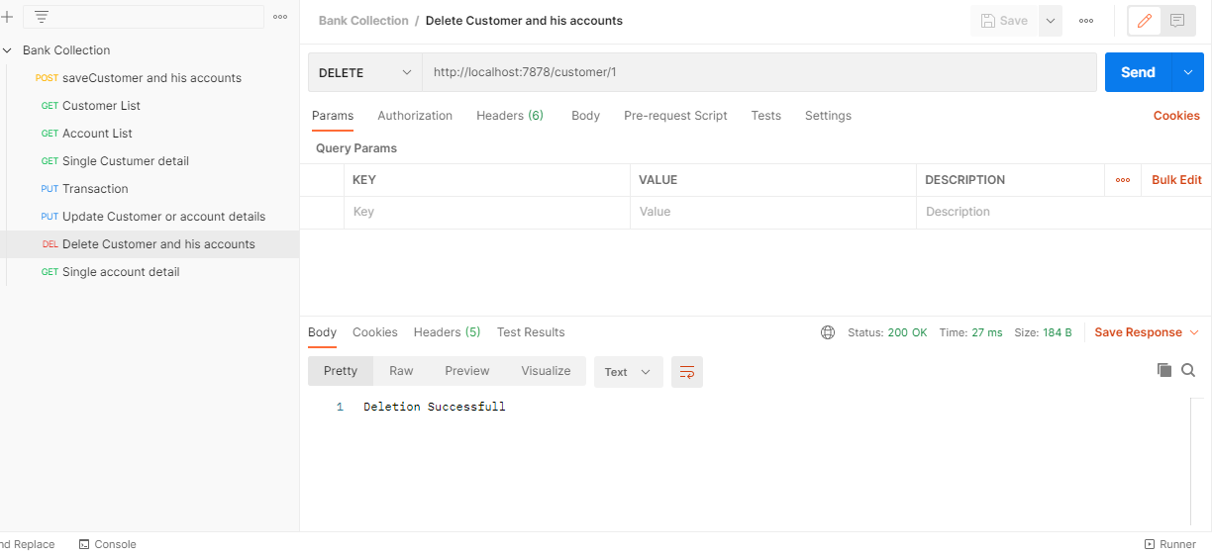
14. Single account detail -Id not found 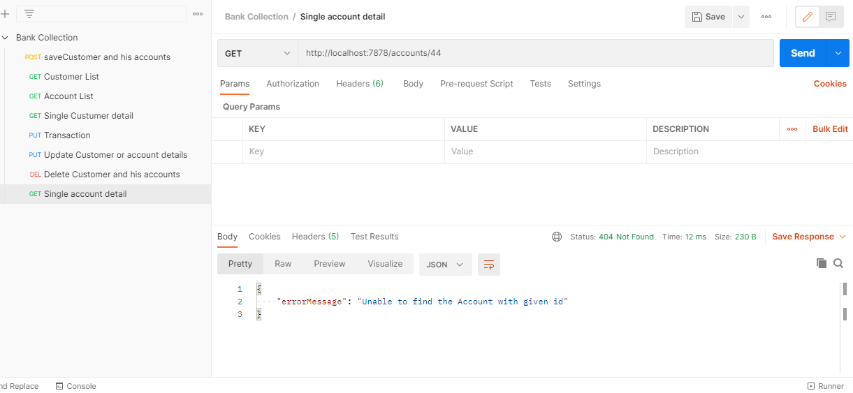
15. Single account detail -Id found 